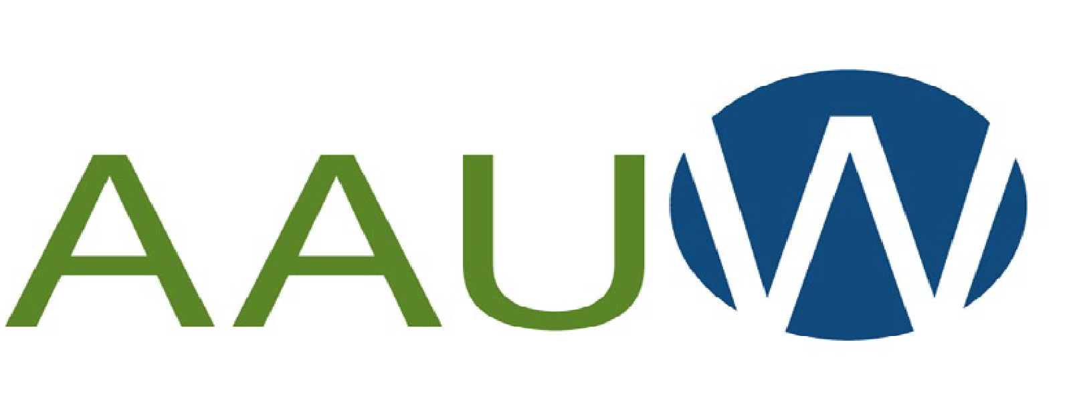

American Association of University Women
Walla Walla Branch
“Advancing equity for women and girls through advocacy, education and research.”

Community Mini-Grant Application – 2022
AAUW raises funds for women’s scholarships and community projects. To be considered for an AAUW-WW Mini-Grant, projects must be local, address our mission, and provide visibility for the branch. The Mini-Grant Task Force submits funding recommendations to the AAUW Board within 30 days of given deadline, then meets quarterly to consider additional requests as funds allow.

DEADLINE: APRIL 15, 2022

Organization Name: ___________________________________________________________

Contact Person: ______________________________________________________________

Mailing Address: _____________________________________________________________

Email: ______________________________________________________________

Phone/text number: ___________________________________________________________

Brief description of the proposed project and specific funding request.

Amount requested: ___________________

1. Details of the proposed project. Be specific. Include attachments or use additional space for your description, as needed. Address all three criteria as stated above.

2. Goals and objectives for proposal.

3. Description of the target population and perceived need.

4. Implementation timeline.

5. Proposed budget for these funds.

6. How will impact and success be measured and documented?
Include a plan for written wrap-up report.

7. How will AAUW’s participation and support be recognized?

8. List additional stakeholders, community partners, and/or funding sources, if any.

Print out and mail to: AAUW Mini-Grants, P.O. Box 12. Walla Walla, WA 99362

OR

Submit electronically to lindalbrown47@gmail.com

Questions? Call Linda at 509-386-7865

